**COMP3025 Interim Report**

**Project title:**

Saving victims’ lives by empowering ambulance services using the power of technology

**Date:**

17th December 2018

|  |  |
| --- | --- |
| Name | Student ID |
| Loh Jin Xian | 016763 |

Name of supervisor : Chew Sze-Ker

**Table of Contents**

|  |
| --- |
| 1.0 Introduction  1.1 Problem Statement  1.2 Motivation  1.3 Background  1.4 Intended Audience  1,5 Aims and Objectives  1.6 Project Scope Description and Limitation  1.7 Timeline (Gannt Chart)  1.8 Milestones |
| 2.0 Literature Review |
| 3.0 Scrum Framework  3.1 Product Backlog  3.2 Release Backlog  3.3 Sprints  3.4 Burndown Chart |
| 4.0 Software Requirement Specification  4.1 Functional requirements  4.2 Non - functional requirements  4.3 UML diagram  4.3.1 Use case diagram  4.4 Prototypes  4.4.1 Low-fidelity |
| 5.0 References |

## 1.0 Introduction

### 1.1 Problem Statement

During an emergency like a fire break or an accident, citizens in most countries will call an emergency number to contact the required departments to save the situations. In this project, we will be focusing on accidents that are related to health or a car accident. Having a universal emergency number in a country is useful to the people to call for help. However, once the person had made the call, several questions like the location of the person and problems faced are asked by a human operator before the call can be relayed to the appropriate department.

In a time of emergency, it is easy to introduce human errors (especially calls made by elderly people that often causes these issues) that might delay the process of having the problem solved. Therefore, by creating an application that automates some crucial tasks like real-time location fetching and user’s information extraction, we can save minutes and seconds that could determine the life and death of the victims involved in an accident.

### 1.2 Motivation

There are many motivations for taking up this project. For example, the number of deaths or serious injuries that can be avoided due to the delay of ambulances is still present in Malaysia. Although traffic jam issue or inconsiderate drivers on the road can be blamed for the delay, every single ambulance calling and ambulance dispatching process should be taken into account to make it more effective and efficient.

Indirectly, the response time of an ambulance could affect the treatment of the patient as the patient that is sent to the hospital in a shorter time has a higher chance of survival by being treated in time. The current ambulance response time set by the former Deputy Health Minister Datuk Seri Dr Hilmi Yahaya is 15 minutes, yet in some cases, the ambulance might take up to 35 minutes to arrive at the destination (Surentheran, 2016). Imagine a world where ambulances services are always available within 5km and anyone can call for an ambulance instantly at any time, anywhere. This is the world that we strive to build, and this project is the first step towards achieving that goal.

Several applications that have the same idea had been proposed and built in the past (e.g. Doctor2U application) but the execution for these applications are different as voice recognition technology will also be implemented in this application to process what the caller is saying to better identify the accident taking place, making it less error-prone.

However, this application is not a mean to replace a human operator but enhancing the procedures of calling for an emergency service. Therefore, the human operator involved should see this application as an extension instead of a replacement and provide services to the user when the application is not sufficient in processing the tasks given.

### 1.3 Background

Life is precious and valuable, yet most humans live their lives without ever being grateful for the opportunity to breathe, see, hear and love in a meaningful way. The realization only comes when he or she is having an emergency or moment that will determine a person’s life and death, only then people will start appreciating what they had in life all these times. However, sometimes a short delay of an ambulance in times of emergency will take away all hopes and dreams of people that want to be better, people that can become future leaders or people that play a major role in society.

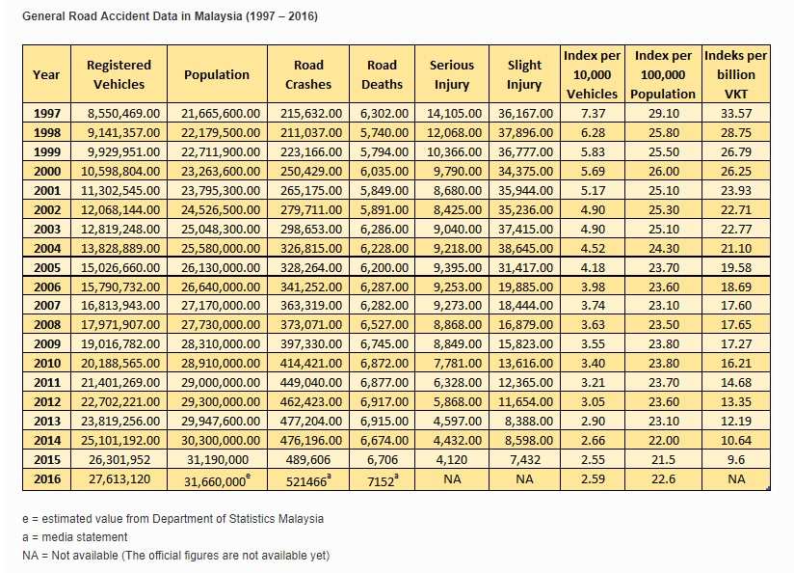

*Diagram 1.3.1 Number of road accidents in Malaysia fromving b 1997 to 2016*

(*General Road Accident Data in Malaysia (1997 – 2016)*, no date)

According to diagram 1.3.1, the number of death related accidents in Malaysia has increased in recent years. At the same time, it has made Malaysia the 3rd highest accidents’ death rates globally, higher than both China and India. The Government has put in a lot of effort to improve the prehospital emergency medical service to compensate the fatality of each car accident. Depending on the situation, most human can loss about 10% to 15% of blood before there is a serious medical concern (eNotes, 2010). Thus, ambulance services must be enhanced to the point of precision where victims of the accident can be sent to the hospital and be treated before serious blood lost that lead to death or coma due to lack of blood flow in the brain. Despite the effort, countless stories of victims died due to the delay of ambulances have been unexpectedly high in recent years although we have made advancement in the realm of technology (Rahman, Shah and Holliman, 2007). There are many reasons that contribute to this issue, one of them is the process of calling for an emergency help.

For example, after dialling the number 999, the caller will be assisted by a professional emergency operator (PEO) that will ask various questions like the emergency involved and the severity of the incident. Other than that, the personal information of the caller like his current location, age and name will also be asked to validate the call. Then, the operator will redirect the caller to the emergency services in need and further assist the caller. The layers of people involved in the call might also introduce undesirable human errors that will again delay the arrival of the ambulance. Therefore, it is not a want, but a necessity to improve the way Malaysians call for an emergency with the help of technology and data.

### 1.4 Intended Audience

The intended audience for this application would be the citizens of Malaysia since the services being offered now are from Malaysia based companies. This will be the case until the application is matured enough to be expanded to the globe. This will be possible by doing more research on how other countries operate their emergency service infrastructures and make modifications to the application to better suit the country’s services.

### 1.5 Aims and Objectives

The aim of this project is to create a mobile application that gives the user the ability to call for an ambulance without going through the usual procedures and ensure the ambulance arrive at the required location using the shortest time possible. The objectives of this project are:

* Using Natural Language Processing (NLP) technology to process what the caller is saying and extract important keywords (e.g. car accident, firebreak etc.) to determine the type of ambulance needed for the situation, thus reducing human error and increasing the precision of the overall emergency system
* Using Global Positioning System (GPS) that is available in the smartphone to determine the location of the caller precisely. By having the location information, the emergency service headquarters will determine the nearest ambulance centre to contact. The location information is then conveyed to the ambulances that will be dispatched with the help of services like Google Map
* Give the user the choices to select which type of hospital (public/private/semi-private) is preferred in times of an emergency and the option to call for a professional emergency officer directly if there are doubts or questions

### 1.6 Project Scope Description and Limitation

In this project, an Android mobile application will be created using a software called Android studio that is provided by Google. This application will have the function to call for an ambulance with just a tap of a button. Besides that, the application uses the Global positioning system (GPS) technology that is available in smartphones to determine the precise location of the user that called for an ambulance. Other than that, it will also include a speech recognition technology that will analyze and extract keywords from the short voice note given by the caller during the ambulance calling process. For example, a short voice notes like “There are two people involved in a car accident”, keywords such as ‘two’, ‘car’ and ‘accident’ will be extracted and interpreted, which conclude that a car accident with two casualties are present and an ambulance with the right equipment for a car accident should be dispatched.

The design of the application will also be minimalistic yet functional, ensuring the learning curve to use the application is gradual. However, there will also be some limitations to the mobile application. As this application is an Android application, it will only work on an Android phone and not on an iOS device. Furthermore, WIFI or mobile data is required to use the application as it needs to send and receive data from the backend server to communicate with the emergency response centres. Although GPS in the application can work without the need of an internet, it is safer to combine both internet and GPS data to pinpoint the location of the caller. At the same time, the voice recognition feature that is present in the application will only work with the English language now due to the limitation of the application program interface (API) being in use.

### 1.7 Timeline (Gantt chart)

(printed Gantt chart stick on physical copy of report)

### 1.8 Milestone

|  |  |  |
| --- | --- | --- |
| **No.** | **Individual Milestone** | **Date completed** |
|  | Function to call for ambulances is reliable | 1 December 2018 |
|  | The live location of the user can be sent to the driver of the ambulance | 25 December 2018 |
|  | Keywords can be extracted and interpreted successfully from the processed voice note | 15 January 2019 |
|  | Voice note from the user can be processed, analyzed by the speech recognition technology | 25 January 2019 |
|  | The required ambulance is dispatched based on the info received | 12 February 2019 |

## 2.0 Literature Review

The Malaysian Emergency Response Service (MERS), which is an integrated system to automate emergency call taking and dispatching, was founded in 2008 by the Government with the initiative to consolidate all emergency numbers in Malaysia into a single emergency number (999) for public conveniences. MERS 999 concept was inspired by 9-1-1 National Emergency Number Association (NENA) and European Emergency Number Association (EENA) which is responsible for emergency calls in North America, Canada and Europe countries. MERS 999 has access to five emergency departments in Malaysia which are the Royal Malaysian Police, Fire and Rescue Department, Health Ministry, Civil Defense Department and Malaysian Maritime Enforcement (Anas, 2012).

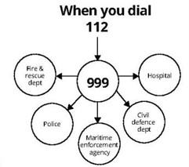

*Diagram 2.1 Departments that can be accessed by dialling 112 or 999*

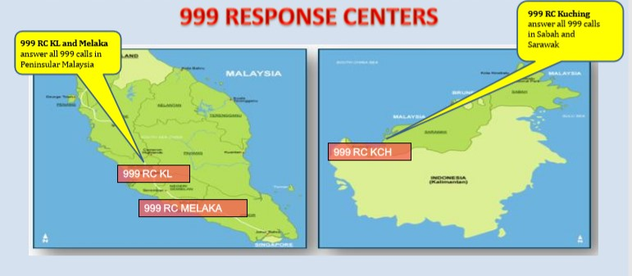

*Diagram 2.2 Response centers location in Malaysia*

As seen in diagram 2.2, there are a total of 3 response centres in Malaysia. When an emergency call is made by the caller, the call will be relayed to the nearest response centre and answered by a professional emergency operator (POE) within 20 seconds. The operator will then ask the caller for some basic information such as location, address and contact number to verify the genuineness of the call. Once the call is verified, the call will be relayed to the appropriate department to aid the caller (Chin, 2015). The diagram below shows the flowchart of the call taking process at a 999 response centre:

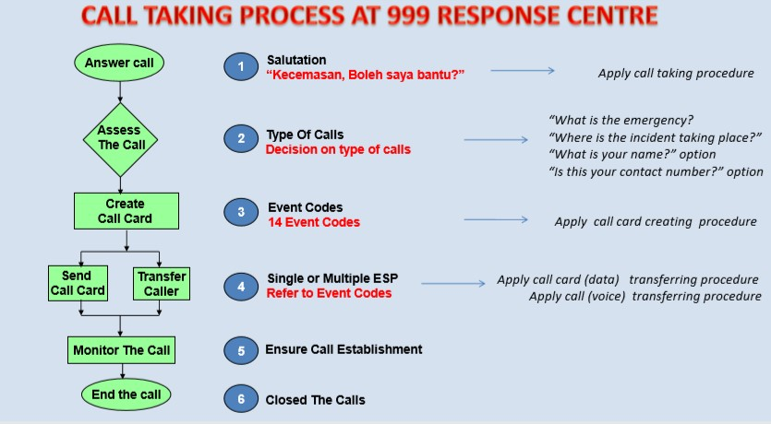

*Diagram 2.3 Flowchart of call taking process for MERS*

In the meantime, the project will focus solely on the ambulance emergency service department. The Emergency Medical Service (EMS), which is a system involving multiple people and agencies that are responsible for providing emergency medical care (*What is EMS?*, no date), is composed of 3 main tools:

1. Computer Telephony Interface (CTI)

* Cutting-edge computer telephone technology delivers the latest tech in call processing to filter spam calls
* CTI integrates with the emergency lines allowing to delimit safety parameter from an address and instantaneously produce an exhausting list of addresses

1. Computer Aided Dispatching (CAD) system

* A powerful real time command & control process, that tracks information relating to all calls and field unit activities
* Captures incident related information, resource availability, resource status & resource recommendation

1. Geographical Information System (GIS).

* Integrated to the CAD System as a tool in visualizing the overall situation
* Can visualize location of calls, incident, vehicles & resources tracking through GPS & Automated Vehicle Location System (AVLS)

Given the sophistication of the system, the system is still not a perfect solution as there are a few challenges:

* Difficulties to determine the precise incident location (5km or more radius)
* Data accuracy from cellular provider (Longitude and Latitude) and profile of the caller might be different

* Geocoding process must be improved continuously due to dynamic movement of the telephone subscribers and new development of residential areas
* Geographical Map in the system has to be updated because of changing landscape due to constant new developments in the area

* Sharing of common information among all agencies must be consistent

By examining the challenges faced by the system, it is safe to conclude that the process of locating the caller is complicated and maintenance of the system is time consuming. Hence, the proposed mobile application is designed to decrease the complexity of the system and ease the software maintenance development process.

The current flow of calling for an ambulance works in the following way:

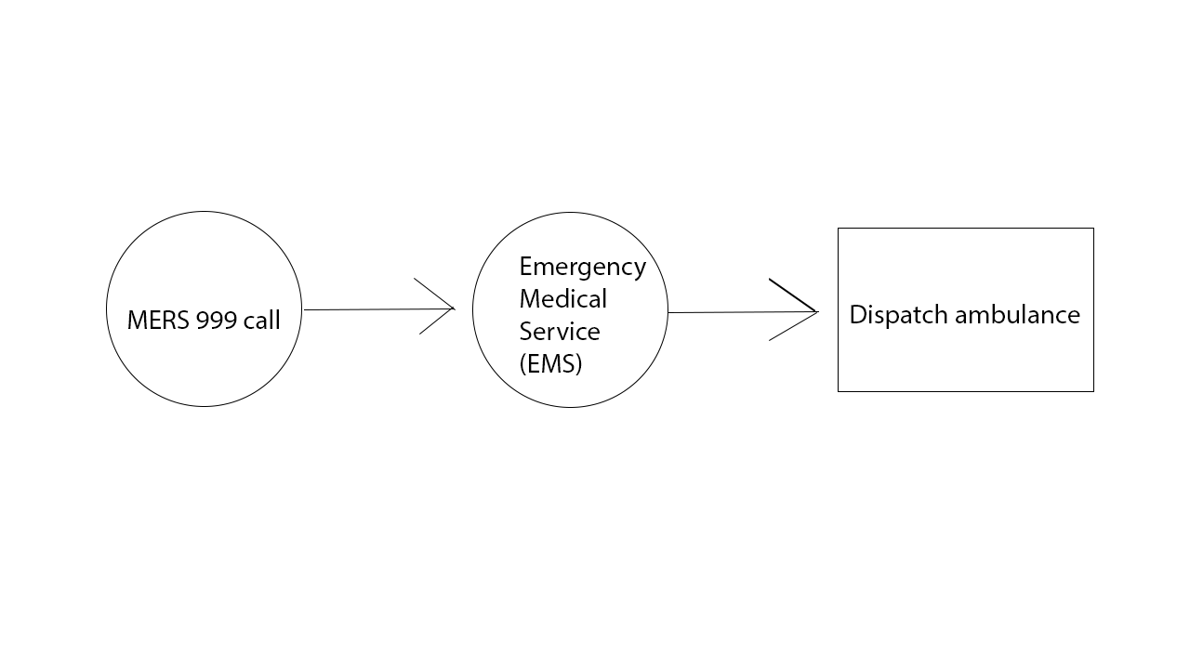Although a phone call is a familiar way of calling for an emergency help, the services should also be further extended by giving the public direct access to the EMS through the use of mobile application. This change in paradigm can be visualized in the following way:

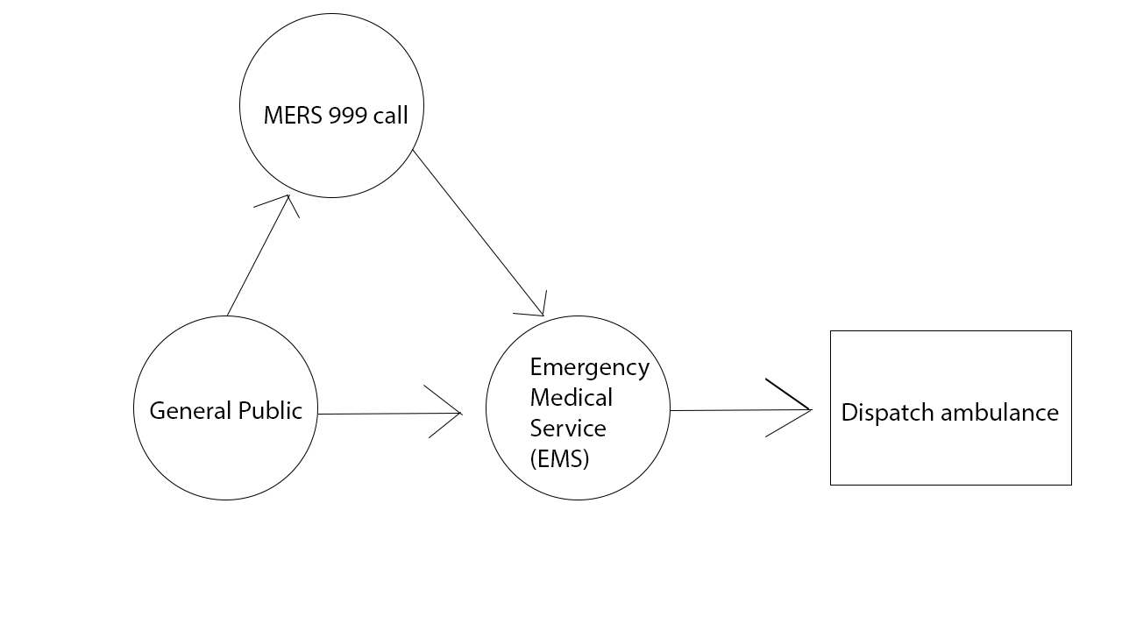

With the newly designed flow, the public can directly contact the EMS for an emergency instead of going through MERS 999, which will now act as an extension to the service by providing assistance to the caller if needed.

According to Pieterse & Olivier (2012), the usage of smartphones has been on the rise, making Android operating system one of the most prominent mobile operating system in the world (Pieterse and Olivier, 2012). Since the purpose of an EMS is to provide immediate medical help in an emergency, having a mobile application developed for this purpose is essential. The core of this mobile application will be depended on the Global Positioning System (GPS) that is present in every smartphone. GPS works by having multiple GPS satellites broadcasting radio signals to the GPS device which then uses the information received (locations, status, precise time) for the geometrical calculation to get the location on Earth in three dimensions (*How GPS works*, no date). This will ensure that the location data is in real-time and streamline the process for the ambulance driver to travel to the intended location in time. Moreover, the complexity of the Geographical Information System (GIS) present in EMS can be replaced by GPS real time location, ensuring always up-to-date data with the assistance of Google Map application programming interface.

In a time of emergency, human errors are easily introduced unintentionally. Therefore, implementation of a voice recognition technology in the mobile application is used to reduce human errors. When user tapped on the button to call for an ambulance, a short timeframe window will be available to the user to send a voice note. Voice note is preferred over text messaging as speech conveys more information and proper identification. The voice note is analyzed by the voice recognition technology and specific keywords extracted will be sent to the EMS to choose the appropriate ambulance to be dispatched. Voice recognition technology: speech-to-text work by incorporating different type of speaker model, type of vocal and speech utterance (Das *et al.*, 2015). Below is an overview of a voice recognition system:

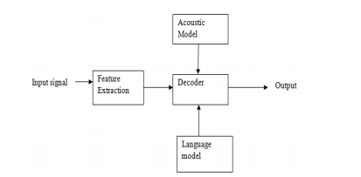

*Diagram 2.4: Overview of Voice Recognition System: Speech-to-text.*

**The explanation for each term**

* **Input signal**

Voice input by the user

* **Feature Extraction**

it should retain useful information of the signal, deduct redundant and unwanted information, show less variation from one speaking environment to another, occur normally and naturally in speech

* **Acoustic model**

it contains statistical representations of each distinct sounds that make up a word

* **Decoder**

it will decode the input signal after feature extraction and will show the desired output

* **Language model**

it assigns a probability to a sequence of words by means of a probability distribution

* **Output**

interpreted text is given by the computer.

Besides solving the location issue, this mobile application gives user the option to choose which type of hospital should the victim be transferred to. In traditional MERS 999 call, all victims can only be transported to public hospitals only. Since half of the public is not satisfied with public hospitals (Hassali *et al.*, 2014), the option of having private or semi-private hospitals available for emergency occasions will improve the overall wellbeing of the public.

Although this mobile application only works when the user has access to the internet and GPS feature on the mobile phone, there will be a button in the application that can dial directly to MERS. This feature is present for two purposes:

1. In the case of emergency where there is no internet available, user can make a MERS 999 call without exiting the application and go to the phone application.
2. When the user can’t describe the accident or incident precisely via the voice note feature, the user can also make a MERS 999 call so that a human operator can assist him or her better.

// how ambnulance app can be expanded to emergency app

The mobile application that is developed for this project only works for ambulancy emergency at the moment. However, this particular application can be expanded further by adding all kind of emergency departments like the Fire and Rescue Department, Royal Malaysia Police etc. to provide assistance to people that are caught in a fire or involved in a home burglary. There will be some difficulties in expanding this mobile application to a global scale as different countries have different laws and regulations that are very specific to each organization. Regardless, the objective of this mobile application which is to provide the ability to call for an ambulance without going through the usual procedures and ensure the ambulance arrive at the required location using the shortest time possible can be realized by adapting and fine-tuning the application to the policies that are set by the Malaysia Ministry of Health.

### 2.1 similar applications that have been developed

Several similar mobile applications have been developed especially in country like India where the response time for ambulances is critically high. In 2017, the chief minister of Chennai just launched a new GPS based mobile application that track the caller’s location via GPS and dispatch ambulance based on the location (Tripathi 2017). Nevertheless, the application doesn’t include any technology besides the implementation of GPS as the core of the service and it received mixed reviews from the public about the reliability of the service.

Another similar application that has been developed is an application called ‘The GoodSAM’ that instantly send a link to the 999 caller’s mobile phone which will open a live streaming video and gives the medics the ability to access the situation before setting off to save the victim. Other than that, GoodSAM application also incorporated a technology that can measure patient’s pulse just from the live video stream. Beta phase feature such as measuring multiple patients’ pulse at once is already planned int the future (Crounch, no date).

One of the more successful ambulance applications is called “Stat” developed by a practicing pediatrician for the last 7 years, Dr. Brian, in 2013. Stat application offered some features that are also present in this project application like the feature to extract user’s GPS location and send the appropriate ambulance help on the spot. The Stat application not only connects users with the nearby idle medical transportation vehicles, but also with en-route medical crews through text, phone and video calls, to keep crews updated on developments. However, the application only works in both states, Philadelphia and Austin, and planned to be further expanded in the future (Hargrave, no date).

// need more stuff here

Needless to say, emergency calling based mobile application still has a lot of room for improvements.

## 3.0 Scrum Framework

### 3.1 Product Backlog

* Database
* GPS integration
* Thumbprint login
* UI design
* Google Map integration
* User account creation
* Multiple emergency departments integration
* Speech recognition technology integration

### 3.2 Release Backlog

* UI design
* User account creation
* Google Map integration
* GPS integration
* Database
* Speech recognition technology integration

### 3.3 Sprints

|  |
| --- |
| **Sprint 1: (1st December 2018 – 31st January 2019)**   * creating account page * creating login page * creating startup page * linking pages together * create button to initiate call * implement GPS information extraction * implement voice recognition technology |
| **Sprint 2: (1st February 2019 – 31st February 2019)**   * creating database using firebase * create UI design * test voice recognition keywords extraction’s accuracy |
| **Sprint 3: (1st March 2019 – 1st April 2019)**   * allow users to edit profile’s information * polish and fix application’s bugs |

### 3.4 Burndown Chart

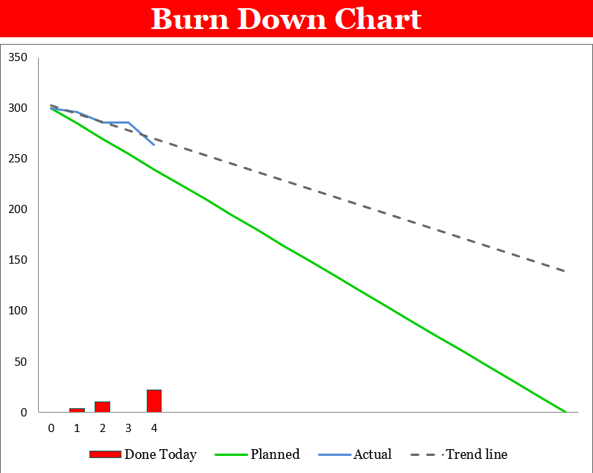

*Diagram 3.1 Burndown Chart*

The burndown chart above corresponds to the Gantt chart for this project. The projected line is the optimum effort for the developer to put in each week. However, there will be setbacks that will delay the process and occasions that will speed up the process. The blue line represents the actual time taken for the developer to create the designed app while the green line is the optimum time taken for the developer to complete the application.

## 4.0 Software Requirement Specification

### 4.1 Functional requirements

1. **Sign up an account**

The user can sign up an account by entering their sign-up details on the sign-up page. After signing up, they are automatically logged in into the app.

2. **Login into app**

If the user is not signed in, the user can log in into the app by entering their login details on the login page.

3. **Sign out**

The user can sign out of the app and return to the main page of the app.

4. **View profile page**

The user can view personal detail on their profile page where their age, weight, height is shown. Besides that, the data for the type of hospital preferred is also available.

5. **Edit profile page**

The user can edit their details on their profile page if needed.

6. **Call for an ambulance / professional emergency operator**

The user can call for an ambulance by a tap of a button in the main page. If the user wants to call a professional emergency operator, there is another button for that function.

7. **Profile authentication**

When the user signs up for the first time, the system will verify all details entered by the user. For example, if the user’s email already exists in the database, the system will return an error saying that the email exists in the database and the user will have to use another email to sign up.

When the user tries to login into the app, the system will validate the email and the password of the user. If any of them does not match the database record, the system will return an error saying that either the email or the password is incorrect.

8. **Updating user database**

Whenever user data is changed in the app, the data will be sent to the database and it will be updated accordingly.

9. **Voice recognition keywords extraction**

When the user calls for an ambulance, there will be a short timeframe for the user to send a voice note. The voice note will be analyzed by the voice recognition technology and extract relevant keywords that will be sent to the emergency medical service.

10. **GPS location extraction**

When the user calls for an ambulance, the application will also extract the live location of the user via GPS in the smartphone and send it to the emergency medical service.

### 4.2 Non-functional requirements

**1. Internet access is required at all time**

The application requires internet access at all time to be able to communicate with the database server when calling for an emergency help.

**2. GPS of the mobile phone must be turned on**

When the user calls for an ambulance, the application will need to access the location of the user via GPS in the smartphone and send it to the emergency medical service.

### 4.3 UML diagrams

#### 4.3.1 Use Case diagram

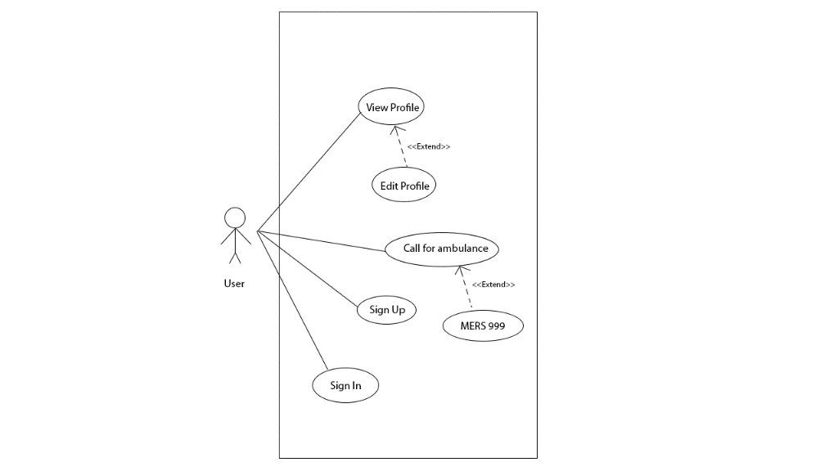

*Diagram 4.3.1 Use case diagram*

The diagram above is referring to how the application works. The user is only allowed the above functions in the app. The use case ‘Edit Profile’ extends ‘View Profile’ because the user has the option to edit his profile information while viewing his profile. Besides that, when the user calls for an ambulance, he or she has the option to contact MERS 999 through the app if there is any additional questions or doubts about an emergency situation.

### 4.4 Prototypes

#### 4.4.1 Low-fidelity

Low-fidelity prototype is a rough sketch on a paper about the basic layout for our app. The following low-fidelity prototype serves as a backbone for our project.

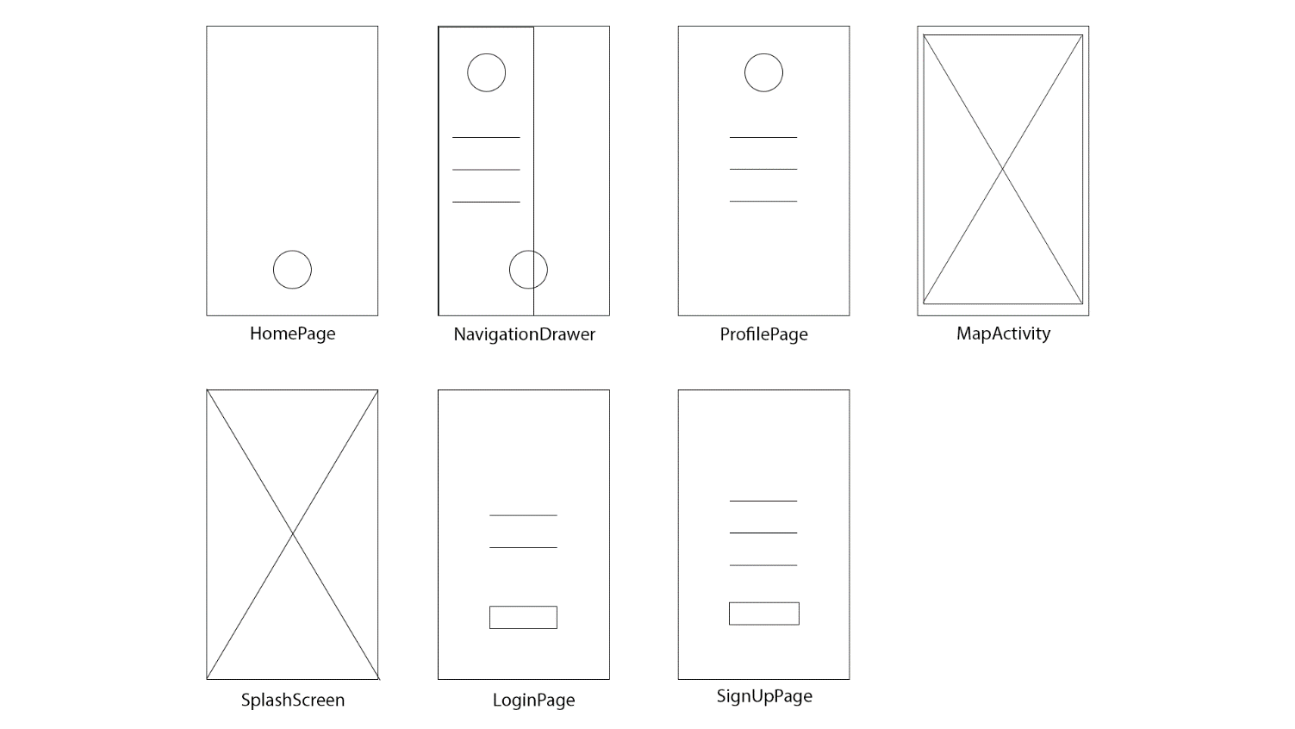

*Diagram 4.4.1 Low-fidelity prototype*

#### 4.4.2 Mid-fidelity

A mid-fidelity prototype will contain a little bit more details compared to low-fidelity prototype. Images, icons and texts will be placed in the layout for better visual enhancement. The following mid-fidelity prototype shows the progress of our current app.

#### 4.4.3 High-fidelity

A high-fidelity prototype will look like a completed design of our project. Everything from UI design, images, texts, hover states etc have been added to the prototype. The following high-fidelity prototype will be our targeted design at the end of our project.

## 5.0 Implementation of project’s application

After a rigorous design process, the implementation of the app is planned and executed. When the implementation phase began, the project team was split into 2 groups. 1 group will be responsible for the user interface (UI) of the app while the other focused on the backend of the app. For the UI team, the built-in game in the app was built using the Unity game engine. In the process, there was a lot of problems as the documentation to implement a game inside an app for the Unity game engine is lacking in depth. Therefore, a lot of time had been spent in solving the problems for the game. After a certain amount of time, the game's implementation problems were finally solved by combining various techniques available at the moment.

Once the game was done, the UI team started implementing the design based on the high-fidelity prototypes that had been prepared during the design phase. However, the UI team was new to the android app development platform. Hence, the UI team started learning how to develop an app for Android from several resources available on the web. Once the UI team had a firm grasp on the process of developing an app, the design of the app can finally be implemented as promised to the client.

As for the backend team, the database server that was provided by Google which is Firebase had an abundance of documentation for newcomers to refer to. It took a considerable amount of time for the backend team to learn the why and how of the system. Thenceforward, the backend team was able to craft an elegant solution to store all the user's information on the server which is accessible to the clients if needed.

After the completion of the game, UI and the database, the teams were recombined to build the step tracker together. At first, the idea was to implement a data extraction system that can extract data from the phone's built-in health tracking app which is Google Fit. Despite the grand idea, the documentation for Google fit service is outdated for a few years, making the implementation unsuccessful after multiple trials and errors. Since the idea was not working as expected, another implementation method was used instead. The team decided to build a step tracker from the ground up that uses the phone's built-in accelerometer to track the user's steps count. This was done by using a combination of API provided by Google and some extra Java codes to store the steps count read from the phone.

Once the steps tracker was completed, the teams started brainstorming idea on how to implement the sleep tracker. Since sleep tracking algorithm was too advanced, a simple solution was adopted by having an alarm clock in the app that tracks what time the user sleep and wake up. Although the sleep tracker had no significant difference when compared to a phone's built-in alarm clock, the sleep tracker provides the user with some virtual currencies if the user successfully achieves the goal of sleeping at least 7 hours a per night, giving the user a reason to use the sleep tracker instead.

Furthermore, the profile page of the app was implemented by gathering all information stored in the database and show them to the user in 1 hub. At the same time, the profile page grants the user the ability to edit their personal information if they wish to do so. An avatar customization feature was also added to the profile page to add a personal taste to the app.

Finally, a location tracker is added into the app by using a third-party library that was able to track the user's location utilizing the phone's built-in Global Positioning System (GPS). Location data is required to help the client identify the user's frequently visited locations thus able to target the users with coupons and vouchers from nearby pharmacies.

## 6.0 Results

## 7.0 References

Anon, 2007. *Emergency medical services at the crossroads*, Washington, D.C.: National Academies Press.

Anas, L. R. (2012) *GIS in emergency communication - The MERS 999 experience*. Available at: http://ngis.mygeoportal.gov.my/ (Accessed: 12 December 2018).

Chin, C. (2015) ‘Public has wrong perception of emergency number’, 15 March, p. 1. Available at: https://www.thestar.com.my/news/nation/2015/03/15/myths-of-112-answered-public-has-wrong-perception-of-emergency-number/.

Crounch, H. (no date) *‘Game-changing’ app allows air ambulance services to view patients*, *Digital Health*. Available at: https://www.digitalhealth.net/2018/05/game-changing-app-ambulance/ (Accessed: 22 March 2019).

Das, P. *et al.* (2015) *VOICE RECOGNITION SYSTEM: SPEECH-TO-TEXT*, *Journal of Applied and Fundamental Sciences*.

eNotes (2010) *‘How fast can someone bleed to death?’* Available at: https://www.enotes.com/homework-help/how-fast-can-someone-bleed-death-178685 (Accessed: 12 December 2018).

*General Road Accident Data in Malaysia (1997 – 2016)* (no date). Available at: https://www.miros.gov.my/1/page.php?id=17 (Accessed: 12 December 2018).

Hargrave, B. (no date) *Stat app is like Uber, but it sends an ambulance*, *USA Today*. Available at: https://www.usatoday.com/story/tech/2013/09/14/stat-app-medical/2631837/ (Accessed: 22 March 2019).

Hassali, M. A. *et al.* (2014) ‘Assessment of general public satisfaction with public healthcare services in Kedah, Malaysia’, *The Australasian medical journal*. Australasian Medical Journal, 7(1), pp. 35–44. doi: 10.4066/AMJ.2014.1936.

*How GPS works* (no date). Available at: https://www.gps.gov/multimedia/poster/poster.txt (Accessed: 19 November 2018).

Pieterse, H. and Olivier, M. S. (2012) ‘Android botnets on the rise: Trends and characteristics’, in *2012 Information Security for South Africa*, pp. 1–5. doi: 10.1109/ISSA.2012.6320432.

Rahman, N., Shah, C. H. and Holliman, C. (2007) *Prehospital Emergency Medical Services in Malaysia*, *The Journal of emergency medicine*. doi: 10.1016/j.jemermed.2006.08.021.

Surentheran, V. (2016) ‘Health Ministry under fire over deadly ambulance cases’, October, p. 1.

*What is EMS?* (no date). Available at: https://www.ems.gov/whatisems.html (Accessed: 19 November 2018).

Tripathi, Shweta. “Mobile App for Better Ambulance Services Launched.” *Deccan Chronicle*, Deccan Chronicle, 3 Nov. 2017, www.deccanchronicle.com/nation/current-affairs/031117/mobile-app-for-better-ambulance-services-launched.html.